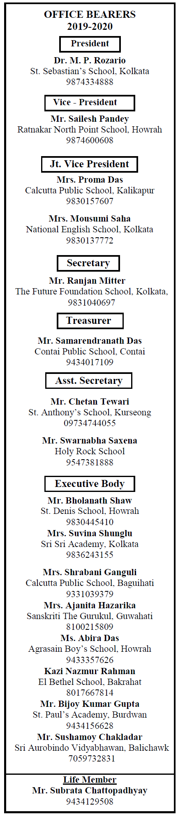

Date: 28th September, 2020

To: The Heads of ASISC Schools

West Bengal & N.E. States

Dear Colleagues,

We are pleased to inform you that the 23rd Annual General Meeting of ASISC, WB & NE States will be held on 14th October, 2020 at 10.30 Hrs on Virtual Platform.

In the light of the challenging environment our schools are faced with, and the consequential need for us to be closer and network better, we solicit your kind presence in the above mentioned Virtual AGM.

We are pleased to inform you that the AGM shall be graced by the National President, National Secretary-Treasurer and National Jt. Secretary.

The Tentative Programme Schedule is as follows: -

**# 14th October, 2020**

* Confirmation of the MOM of the AGM held at Vizag on 20th July, 2019.
* Presentation of Secretary’s Report.
* Presentation of the Annual Audited Accounts by the Treasurer.
* Consideration of Amendments to the Articles of Association.
* Appointment of Auditor for FY: 2020-2021.
* Any other matter with the permission of the Chair.

The AGM will be followed by a special address by Mr. Gerry Arathoon, CEO and Secretary CISCE.

You are requested to kindly register for the conference by clicking on the following link

<https://docs.google.com/forms/d/e/1FAIpQLSd5xKZEfsl8vmOqhEfcacpaxOQPOoBRMHDMUekcbyOWDTV-0A/viewform?usp=sf_link>

The Registration link shall be open till 7th October, 6.00 PM. The Meeting Link shall be shared before 48 hours of the event.

Kindly note only one representative from the member school shall be entitled to attend the Virtual AGM.

You are requested to kindly pay the Annual Subscription of the Association if not already paid. You may choose to make the payment by either of the following options;

1. NEFT, the details are given as follows: Account Holder’s Name – ‘Association of Schools for the ISC, WB Chapter’, Bank – ICICI Bank, Branch – Prince Anwar Shah Road Branch, IFSC Code – ICIC0000540, Account No. – 627801089350.
2. Log in to [www.asiscwbc.org](http://www.asiscwbc.org) and click on ONLINE PAYMENT Section and proceed as directed.

You are requested to send the transaction details to [asiscwb18@gmail.com](mailto:asiscwb18@gmail.com).

Members who had paid the Registration Charges for the Darjeeling Conference shall be contacted separately by the Treasurer/Association to discuss the same further.

Kindly forward this e-mail to other ASISC, WB & NE States member schools in your neighborhood / zone as this information is being sent electronically only and the undersigned is not responsible for assured receipt.

Thanking you,

Yours sincerely,

The Conference Sub-Committee

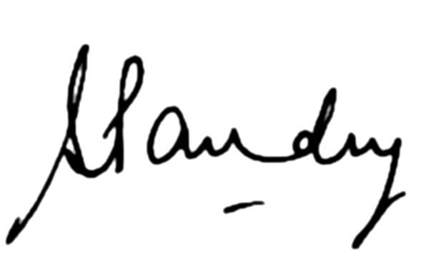  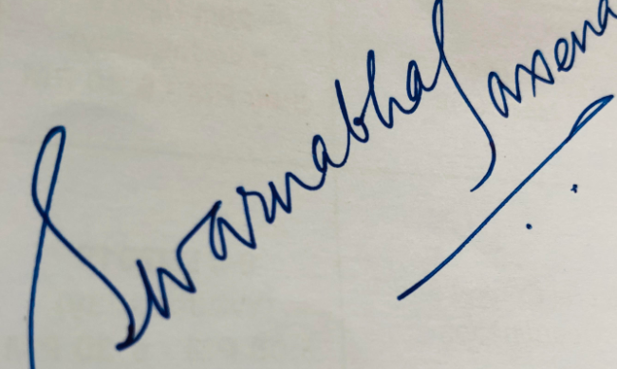

Mr. Sailesh Pandey Mr. Chetan Tiwari Mr. Swarnabha Saxena

Vice President Asst. Secretary Asst. Secretary

ASISC WB & NE States ASISC WB & NE States ASISC WB & NE States