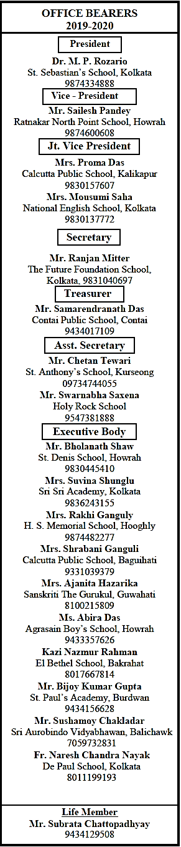

Date: 1st May, 2020

To: The Heads of ASISC Schools

West Bengal Chapter & N.E. States

Dear Members,

As we all know that the pandemic Covid19 is dominating the news cycle as well as the personal and professional lives and we are all in this together. In this unprecedented scenario, the health and welfare of our members and their families remain our utmost priority, and while we continue to monitor the rapidly evolving situation, we shall have to postpone our 23rd AGM & Regional Conference that was scheduled on 12th & 13th of June, 2020 till further notice.

We shall be sharing the re-scheduled date along with other details shortly after the situation is under control and things normalize.

Please reach out to us if you need any assistance, we shall be glad to stand by your side as always

It might be stormy now, but rain doesn't last forever. We can beat it together.

Stay Safe & Stay Connected

.

Thanking you,

Yours sincerely,

The Conference Sub-Committee

Mr. Sailesh Pandey Mr. Chetan Tiwari Mr. Swarnabha Saxena

Vice President Asst. Secretary Asst. Secretary

ASISC WB & NE States ASISC WB & NE States ASISC WB & NE States