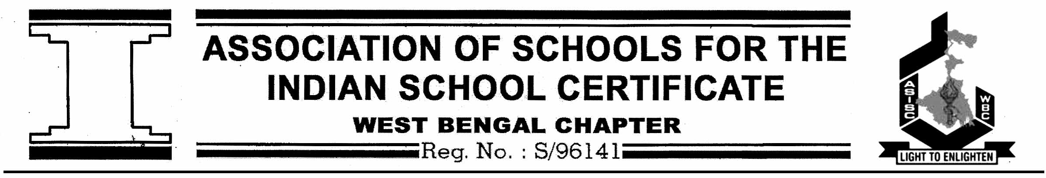
May 14, 2023

To: Heads of all ASISC, WB & NE States Member Schools

Dear Colleagues,
Prayerful Greetings!
As per the Notice dated May 12, 2023, please find attached herewith the Rules & Regulations along
with Registration Links for The Fr. George Hess Literary Competitions of ASISC WB & NE States shall
be held between July 11, 2023 and August 8, 2023. The attached Rules and Regulations are self
explanatory. Please adhere to the instructions given in the Entry Forms.

ASISC WB & NE States Literary Events 2023
Event Schedule
EVENT | DATE | CATEGORY | HOST SCHOOL
CREATIVE WRITING | 11-JUL-2023 | SUB-JUNIOR (VI-VIII) | NATONAL GEMS HIGHER SECONDARY SCHOOL (WB145)
CREATIVE WRITING | 11-JUL-2023 | JUNIOR (IX -X) | NATONAL GEMS HIGHER SECONDARY SCHOOL (WB145)
CREATIVE WRITING | 11-JUL-2023 | SENIOR (XI -XII) | NATONAL GEMS HIGHER SECONDARY SCHOOL (WB145)
PAINTING | 14-JUL-2023 | SUB JUNIOR (VI-VIII) | ADAMAS INTERNATIONAL SCHOOL (WB277)
PAINTING | 14-JUL-2023 | JUNIOR (IX -X) | ADAMAS INTERNATIONAL SCHOOL (WB277)
PAINTING | 14-JUL-2023 | SENIOR (XI -XII) | ADAMAS INTERNATIONAL SCHOOL (WB277)
DECLAMATION | 18-JUL-2023 | SUB JUNIOR (VI-VIII) | PURWANCHAL VIDYA MANDIR (WB223)
DECLAMATION | 08-AUG-2023 | JUNIOR (IX -X) | SRI SRI ACADEMY (WB328)
DECLAMATION | 14-AUG-2023 | SENIOR (XI -XII) | THE BGES SCHOOL (WB160)
DEBATE | 01-AUG-2023 | JUNIOR (IX-X) | THE BSS SCHOOL (WB446)
DEBATE | 02-AUG-2023 | SENIOR (XI-XII) | THE MODERN HIGH SCHOOL FOR GIRLS (WB218)
QUIZ | 05-AUG-2023 | SUB JUNIOR (VI-VIII) | St. XAVIER’S INSTITUTION, PANIHATI (WB108)
QUIZ | 04-AUG-2023 | JUNIOR (IX -X) | DELHI PUBLIC SCHOOL, NEWTOWN (WB294)
QUIZ | 03-AUG-2023 | SENIOR (XI -XII) | THE BHAWANIPORE GUJRATI EDUCATION SOCIETY SCHOOL (WB160)

Registration Links
EVENT | CATEGORY | REGISTRATION LINK | LAST DATE OF REGISTRATION
CREATIVE WRITING | SUB-JUNIOR (VI-VIII) | https://forms.gle/ZQb9Dqy76QXKBmcQ9 | 30- JUN-2023
CREATIVE WRITING | JUNIOR (IX -X)
CREATIVE WRITING | SENIOR (XI -XII)
PAINTING | SUB JUNIOR (VI-VIII) | https://forms.gle/bTbgf4Ufvegn792T9 | 01-JUL-2023
PAINTING | JUNIOR (IX -X)
PAINTING | SENIOR (XI -XII)
DECLAMATION | SUB JUNIOR (VI-VIII) | https://forms.gle/g3rbJrYqQ4f5YUq1A | 03-JUL-2023
DECLAMATION | JUNIOR (IX -X) |  | 20-JUL-2023
DECLAMATION | SENIOR (XI -XII) |  | 01-JUL-2023
DEBATE | JUNIOR (IX-X) | https://forms.gle/htG33TBiCtLyn6kf8 | 15-JUL-2023
DEBATE | SENIOR (XI-XII)
QUIZ | SUB JUNIOR (VI-VIII) | https://forms.gle/CeGQ2teVUY1dfjws9 | 20-JUL-2023
QUIZ | JUNIOR (IX -X)
QUIZ | SENIOR (XI -XII)

- All Competitions (Except Debate) will be held in three categories: -
Sub-Juniors - Students of VI, VII & VIII
Juniors - Students of IX & X
Seniors - Students of XI & XII
- Debate will be held in two categories Junior (Students IX & X) & Senior (XI & XII).
- Only the winners of each category from the respective region will participate in the National competition.
- Participation Certificates will be awarded to all participants.
- Winners of the First, Second and Third positions will be awarded Merit Certificates.
- A panel of judges will compile all the results. The decision of the judges will be final and binding.

NO ENTRIES SHALL BE ACCEPTED AFTER THE LAST DATE OF REGISTRATION

Wishing our students all the very best for the competitions.

Thanking You

Yours truly,

Members of the Literary Events Sub-Committee

Ms. Proma Das Ms. Mousumi Saha Ms. Seema Sapru

